

Creature Creation Activity

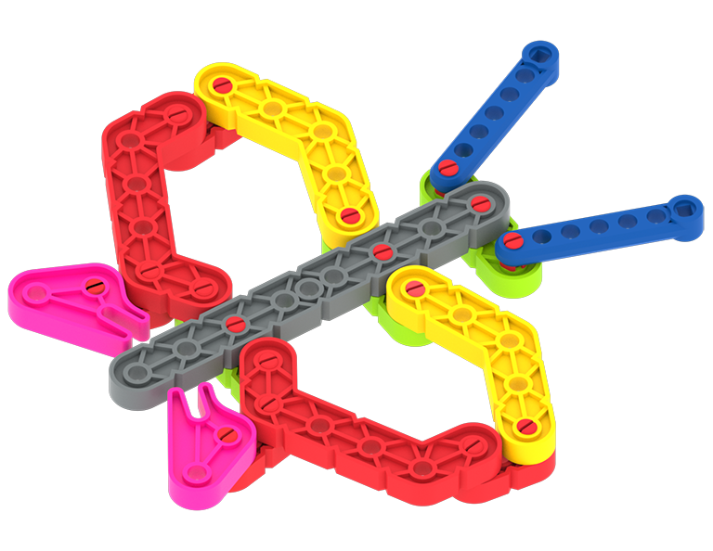 | Design and build a VEX GO creature!

Challenge Goal: Use pieces from the VEX GO Kit to design and build an animal or insect of your own.

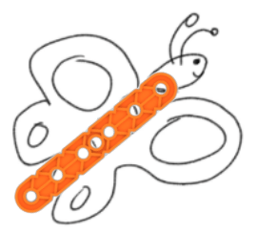
Step by Step:
- Think of a favorite animal or insect.
- Draw it on a piece of paper.
- Look at the pieces in the VEX GO Kit. Which pieces can be used to make each part of your creature?
- Gather the pieces and lay them out on the table, to see how they match up with what you pictured.
- Once your pieces are laid out to match your drawing, connect them together to create your creature!

Pro Tips
- Think in shapes! What is the shape of each feature? What pieces from the GO Kit are similar?
- Make a rough draft. Your first try may not turn out as you expected. That is okay! Use it as a rough draft and keep making small changes.
- Keep an open mind. As you build, your creature may start to look like another. Don’t be afraid to change your plan as you are building.

Creature Creation
Activity Notes

Hands-on time for this activity is approximately 1 hour.

Preparing for the Activity

Additional materials needed for each group (recommended group size is two students):
- Paper and Markers (for planning the build)

Facilitating Creature Creation

- Introduce the activity. Share the context here to help students connect what they will do with the GO Kit to real-world applications.
 | Engineers and designers often begin with an idea: a creature, a shape, a movement, or a feature they want to bring to life. In the Creature Creation activity, your group will use pieces from the VEX GO Kit to design and build an animal or insect.  You will start by imagining what you want to create, then think carefully about which pieces can represent the body parts, shapes, and features of your creature. As you build, your first idea may change. A beam might become a leg, a plate might become a wing, or a connector might help your creature stand in a new way. Keep testing, adjusting, and improving your design as you work.  Focus not only on what your creature looks like, but on how your team shares ideas, makes choices, and turns imagination into something real.

- Share the examples in the pictures above, and ask students to try to match the parts of butterfly, goose and turtle to pieces they see in their VEX GO Kits.
  - Use the VEX GO Interactive Parts Poster to help them name the pieces.
  - Show them how to use pins to connect pieces. Then demonstrate how to use the Pin Tool to pry the pieces apart and remove the pin.

- Direct students to start the Creature Creation Activity.
  - Share with students that they will have 15 minutes to build. Extend or shorten this time as needed to fit your setting.
  - As students build, move around the room and talk with students, asking questions like:
    - What pieces are you using for each part of your creature?
    - How are you ensuring each member of your group is contributing to the project?
  - Use the images for inspiration, if students need help getting started with their creature ideas.
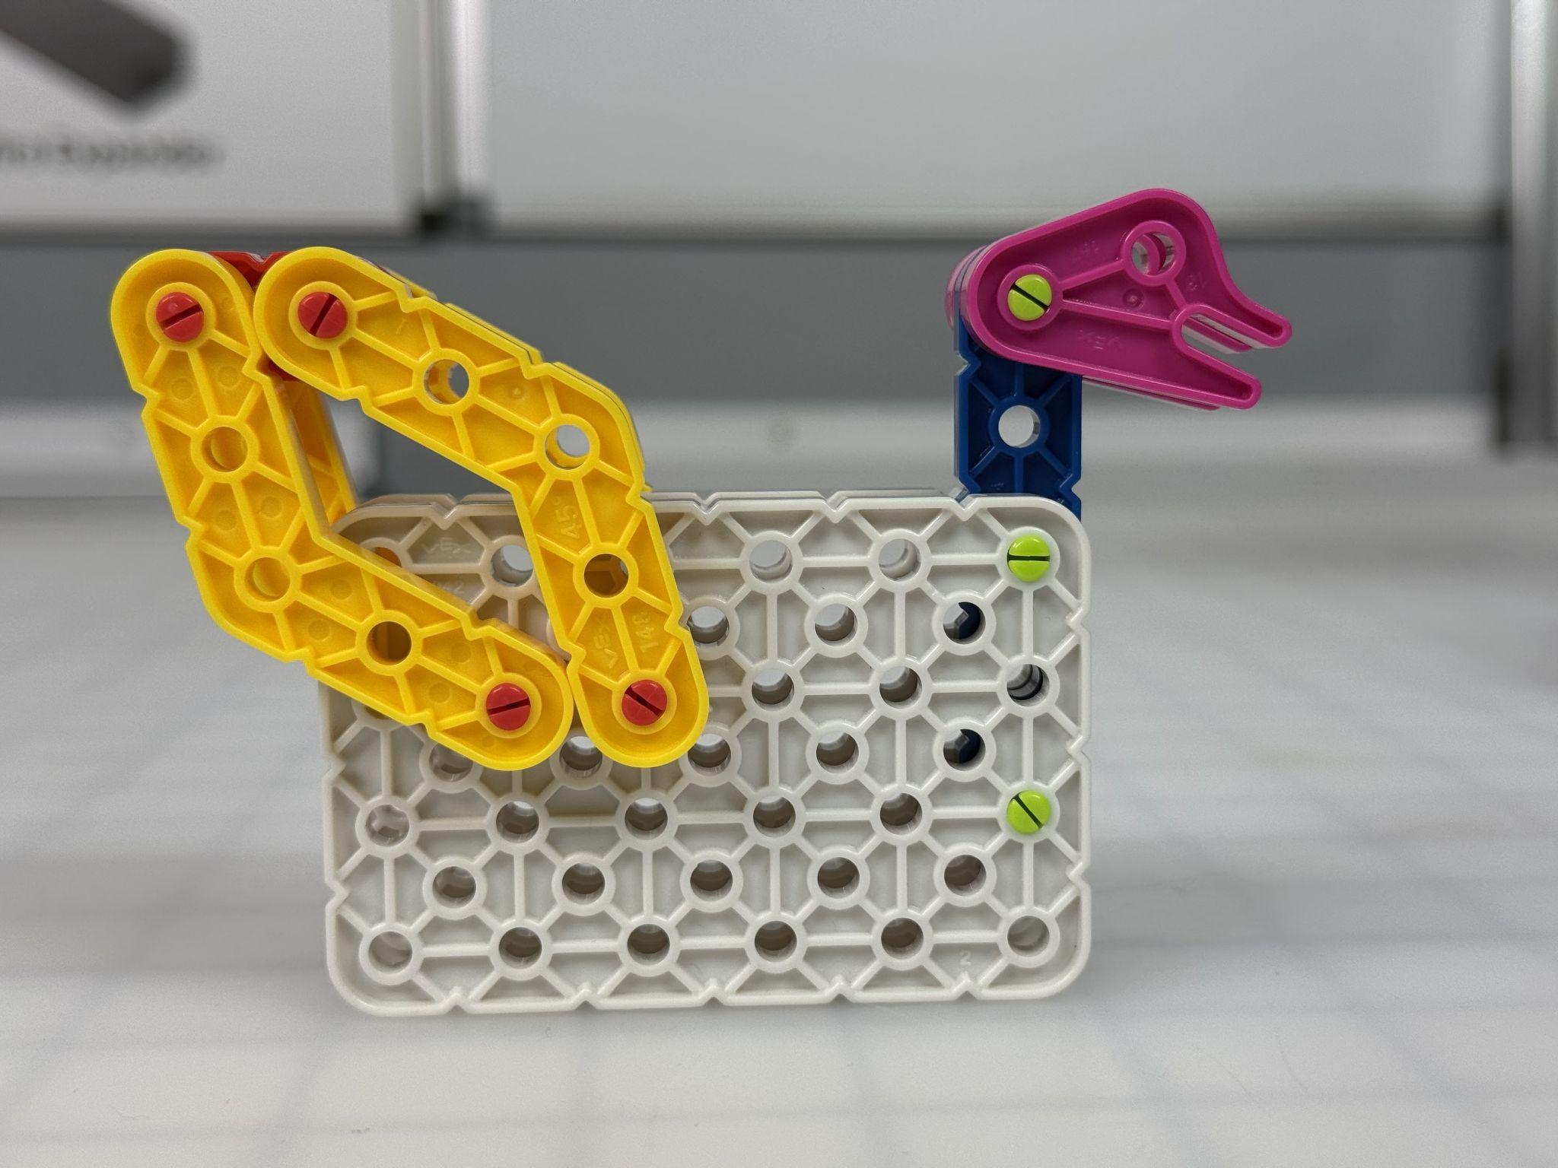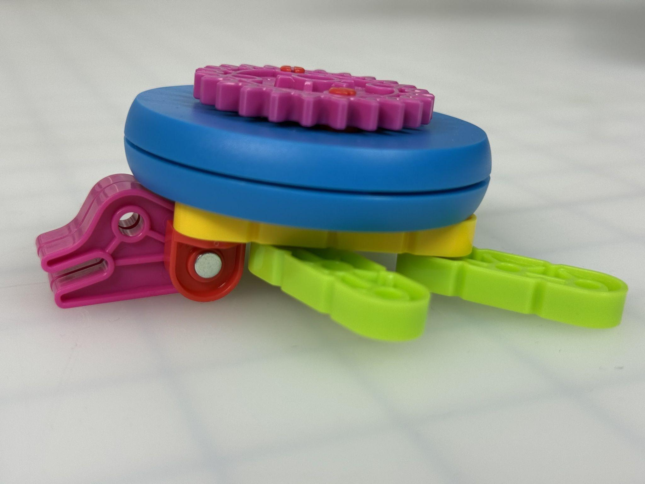

- Direct students to pause and scout.
  - After students have had 20 minutes of time to build, have them pause and circulate through the room to see how other groups are approaching their creatures.
  - Students can ask each other questions and make observations that they can apply to improve their creatures.

- Give students an additional 10 minutes to modify their designs based on what they saw during the scouting break.

- Wrap Up the Activity. Refer to the Instructor Notes for details. Share pictures of your VEX GO zoo!

Extending the Activity

- Create a habitat for your creature! Have students use the remaining pieces in the kit to build a habitat for their animal or insect.
  - Have students incorporate drawings if desired.

- Make it Move! Challenge students to add or change connectors on their creature builds to add movement.

